Here I am describing API deployment strategy of NodeJS in CF Environment using API Management Service.

**Step 1:** Go to API Management service and click on Access API Designer.

The below URL will be opened.

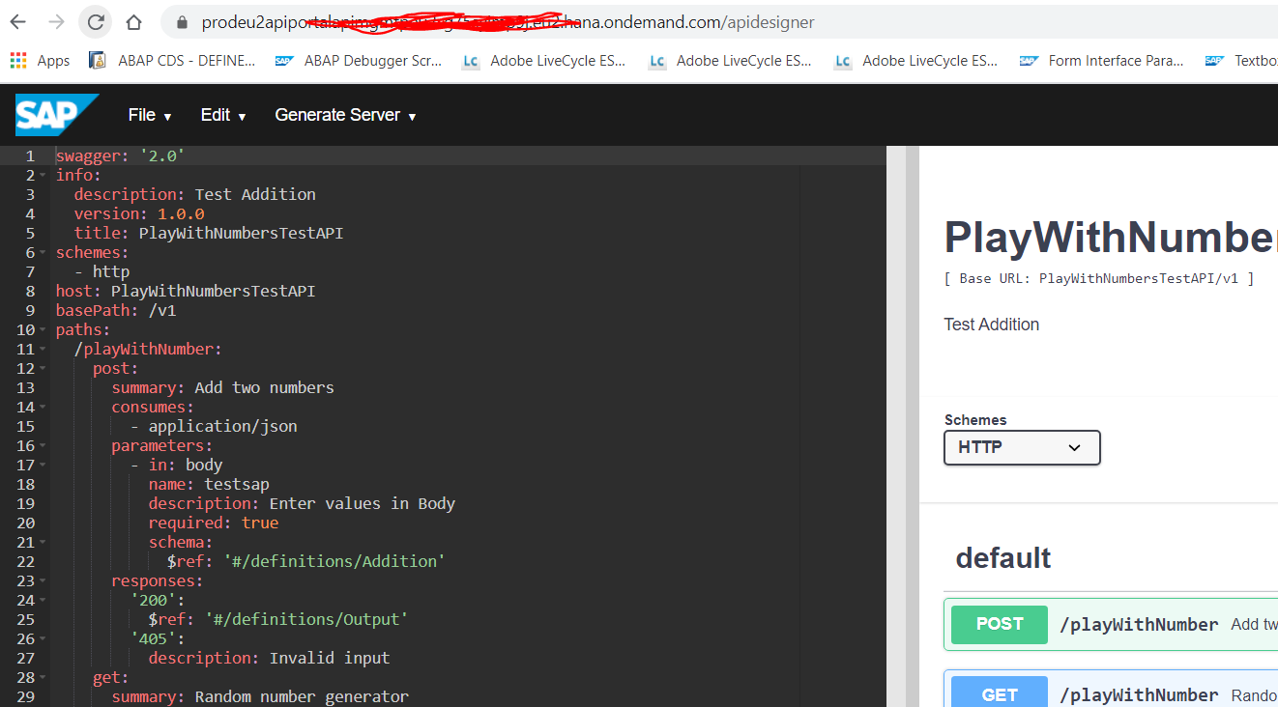

**Step 2:** Update the YML file according to the requirement

**Step 3:** Click on the highlighted option and give the details in the corresponding fields

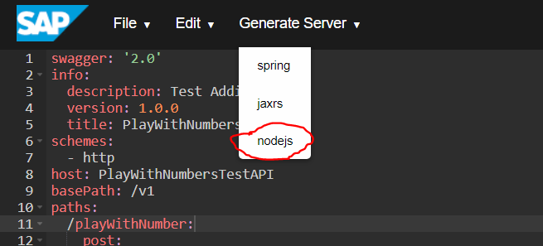

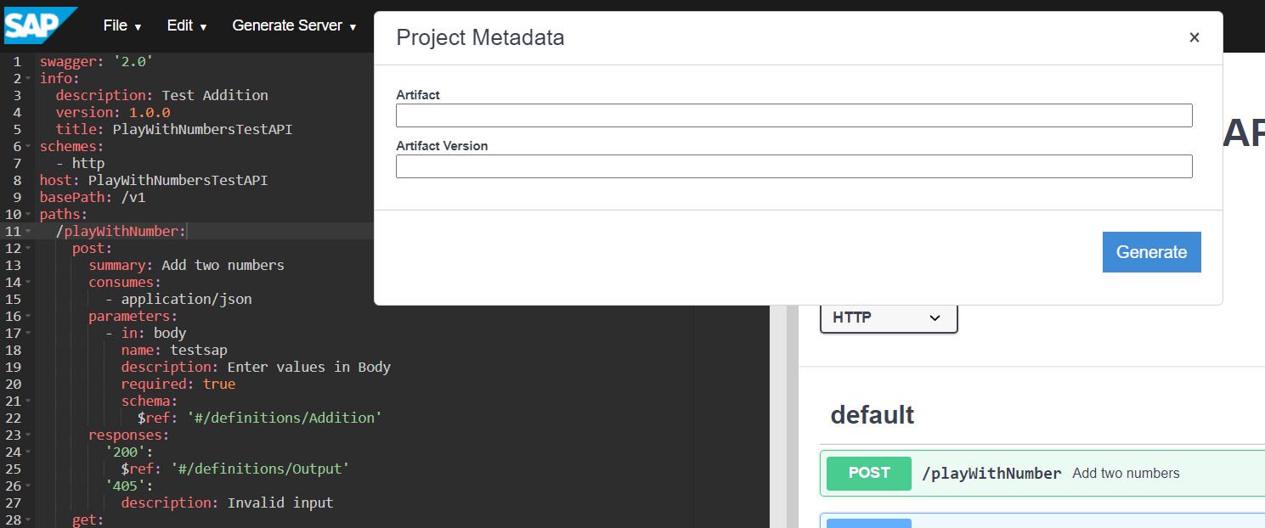

**Step 4:** Get VS Code installed and open the folder in the workspace.

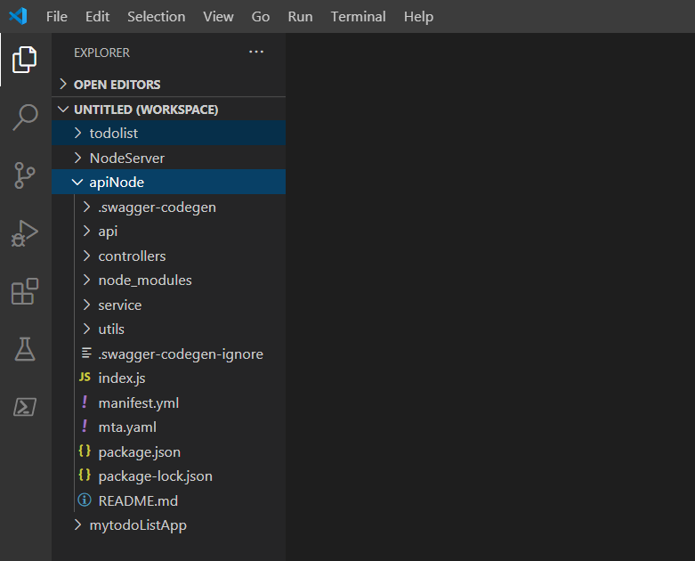

Click on Terminal and click on the

npm install

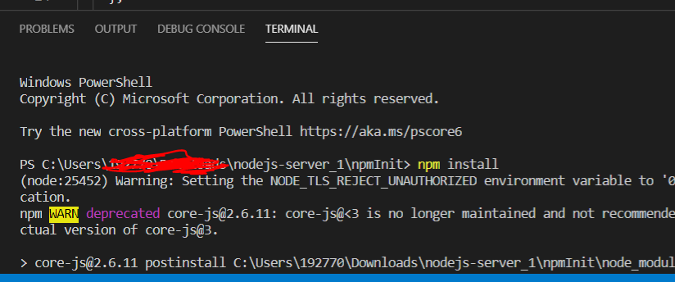

npm install random-number

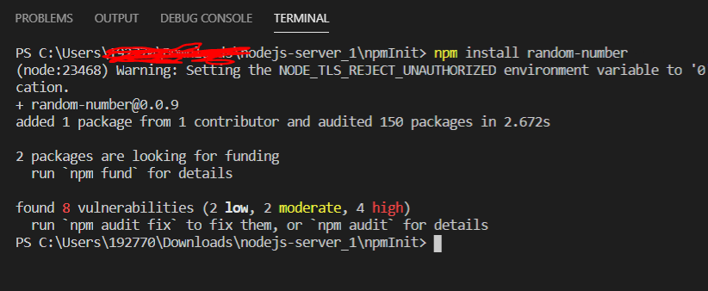

npm start

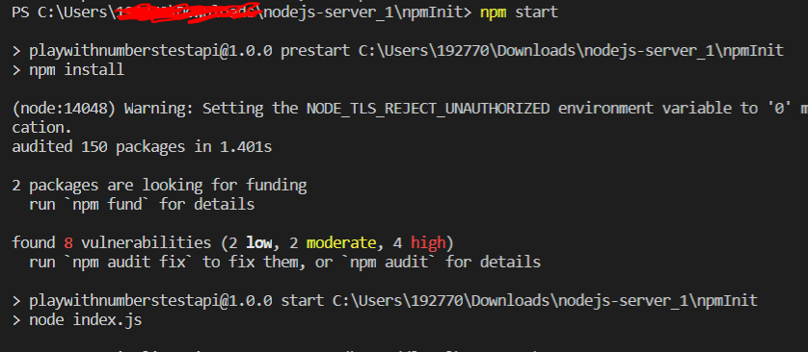

By default the local server will run at: http://localhost:8080/docs

**Step 5**:

Update the Default.js from the url: <https://github.com/sabarna17/SCP_API_Management/blob/master/Default.js>

Then redeploy the API and test the API:

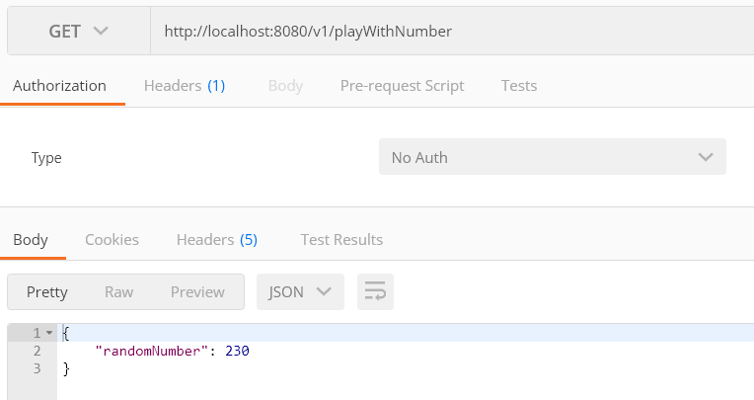

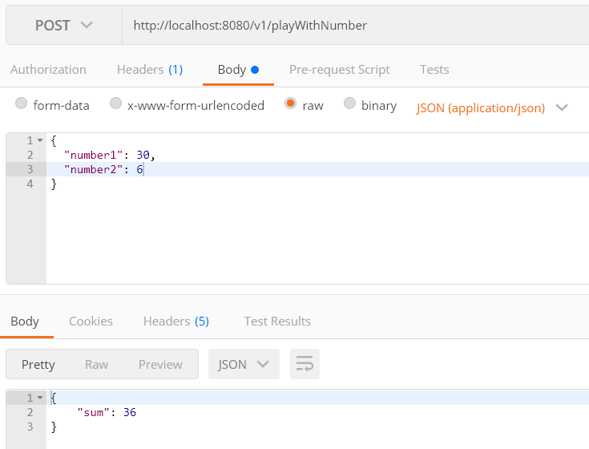

**Step 6:** Now lets deploy this.

Update manifest.yml from the url: <https://github.com/sabarna17/SCP_API_Management/blob/master/manifest.yml>

Install CF7 from the below url:

[**https://packages.cloudfoundry.org/stable?release=windows64&version=v7&source=github**](https://packages.cloudfoundry.org/stable?release=windows64&version=v7&source=github)

* Once installed, goto cmd and use the below code to login to

**cf7 login -a https://api.cf.eu10.hana.ondemand.com -u {loginid} -p {password} -o {orgName}**

**cf7 push -f manifest.yml**

Cloud API is now deployed.

Login to the SCP CF to see the latest deployed API.